

**School Of Computer Science**

**Department of Cybernetics**

**GRAPHICS & ANIMATION**

**TOOLS LAB FILE**

**Submitted By Under Guidance of**

**Pranay Gaur Dr. Durgansh Sharma**

**B.Tech CSE-OSSOS Associate Professor**

**500062466 Dept. of Cybernetics**

# Experiment 1

Aim: Installation of GIMP AND BLENDER.

Step 1:

Download GIMP from <https://www.gimp.org/downloads/>

Download Blender from <https://www.blender.org/download/>

Step 2:

Open Installation file, and click on install/ next.

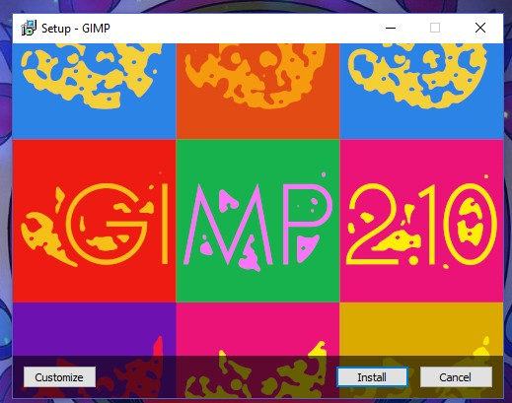

**FIGURE 1: GIMP INSTALL SETUP FIRST LOOK**

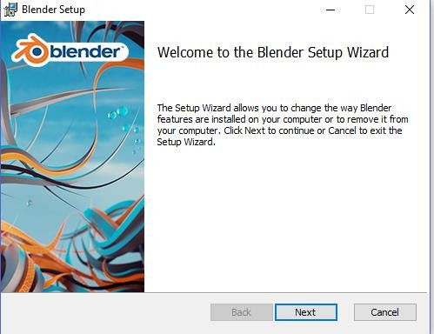

**FIGURE 2: BLENDER INSTALL SETUP FIRST LOOK**

Step 3: Installation done, Now open the softwares.

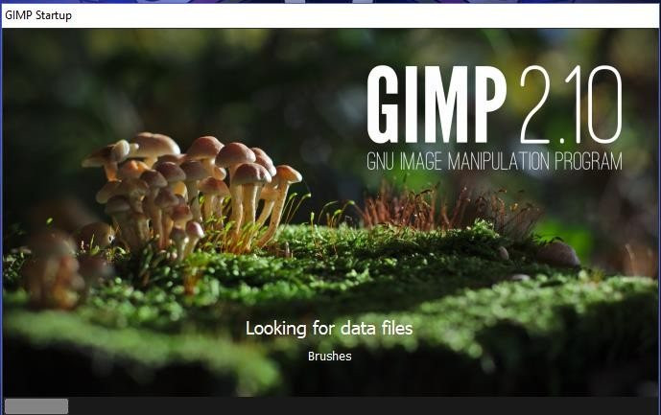

**FIGURE 3: GIMP FIRST LOOK AFTER INSTALLATION**

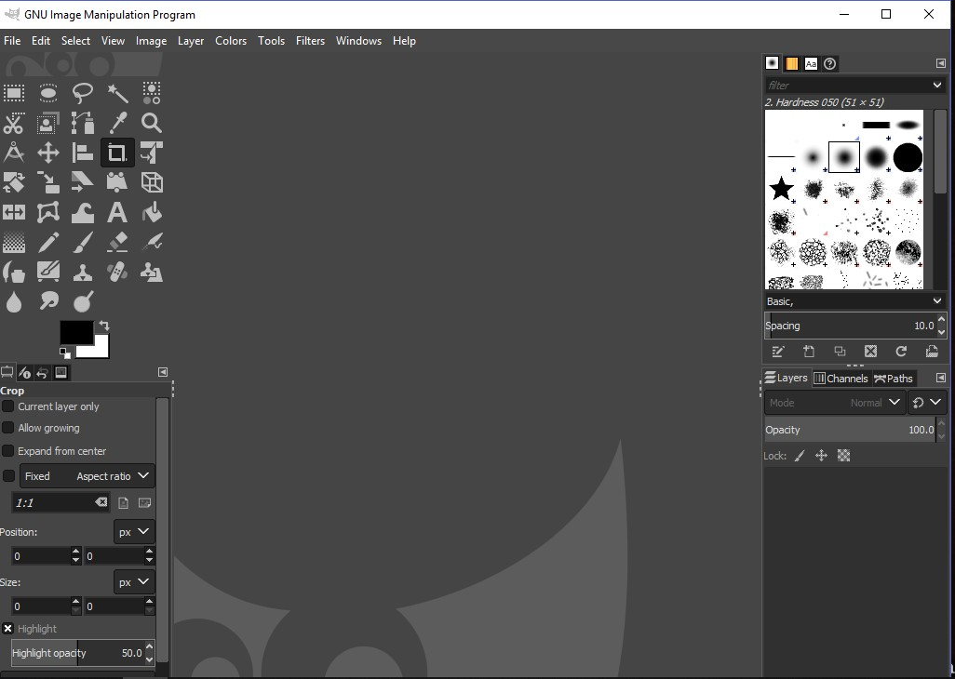

**FIGURE 4: GIMP UI**

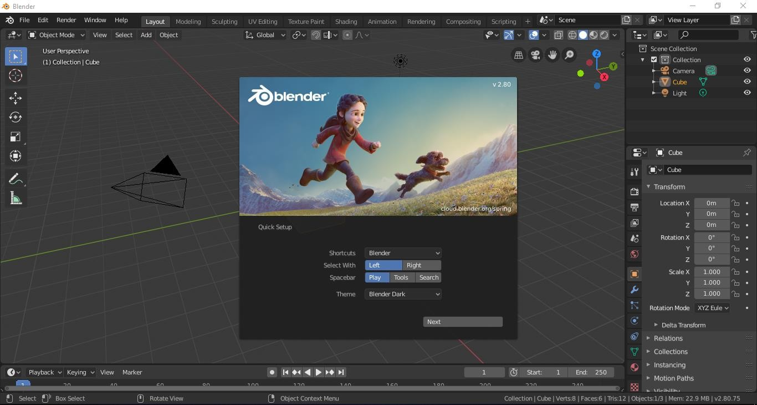

**FIGURE 5: BLENDER UI AND FIRST LOOK**